These are the guidelines to define a specific issue, difficulty, contradiction, or gap in knowledge that you will address.

PROBLEM STATEMENT
‘I would like to clarify my priorities by focusing on these key critical points’

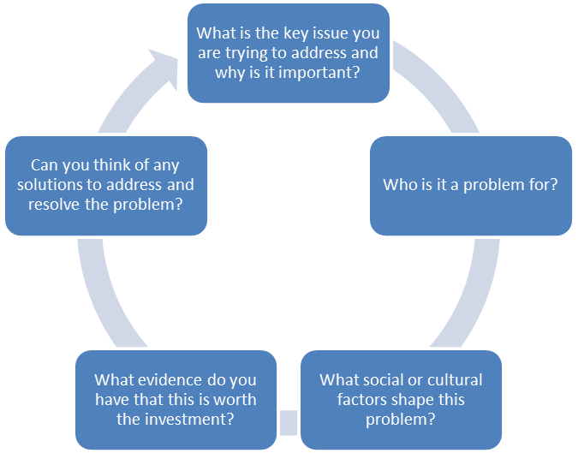

- Problem statement formulation: what is the key issue you are trying to address?  - Who does the problem impact and involve?  - Why is solving the problem important for stakeholders? (consequences)  - Describe the current state of affairs  - What are the reasons / drivers of the problem? What factors shape the problem?  - What evidence do you have that this problem is worth the investment?(consequences)  7 Possible solution | 1 Формулировка заявления о проблеме: какой ключевой вопрос вы пытаетесь решить?  2 С кем связана проблема?  3 Почему решение проблемы важно для заинтересованных сторон? (последствия)  4 Опишите текущее положение дел  5, Каковы причины / водители проблемы? Какие факторы формируют проблему?  6 Какие доказательства того, что эта проблема стоит инвестиций? (последствия)  7 Возможное решение

This is how you address the shared context, your perception of the problem and the possible solution.

Problem Statement: An Example of Ordering
How would you order this text?
1. Advances in nanotechnology make it possible to explore the role played by water molecules in living systems,
2. but the confinement of water molecules in sub-nanometer channels in biological systems has received relatively little attention
3. potentially leading to the development of ultrasensitive biosensors.
4. The properties of water at the nanoscale are crucial in many areas of biology,
Check the answer here
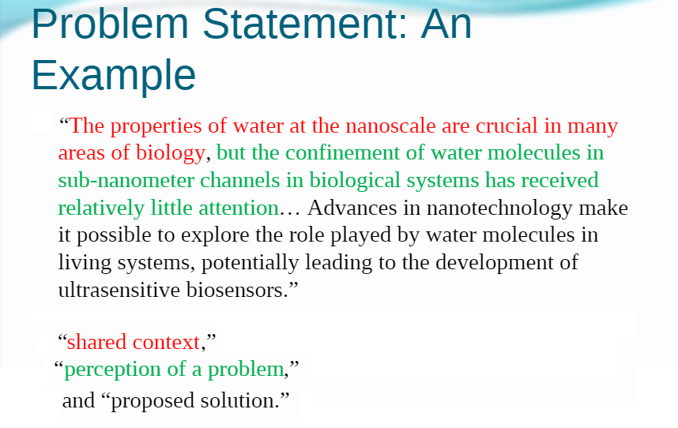
Some expressions to use in your problem statement
- There has been a ………
- Due to……
- Therefore, ….
- If the situation has not been remediated and continues, it will surely …….. Additionally,……
- As a result, ………

